FUNCTION POINTS
Function Point Analysis (FPA) is a standardized method used to measure the functional size of a software system independently of the technology or programming language. The method evaluates the functionality delivered to the user, based on clearly defined function types.

1) USER STORIES CLASSIFICATION
First thing, we have classified each user story as one of this functionality:
• Internal logical file (ILF) An ILF is a user-identifiable group of logically related data or control information maintained within the boundary of the application. The primary intent of an ILF is to hold data maintained through one or more elementary processes of the application being counted.
• External interface file (EIF) An external interface file (EIF) is a user identifiable group of logically related data or control information referenced by the application, but maintained within the boundary of another application. The primary intent of an EIF is to hold data referenced through one or more elementary processes within the boundary of the application counted. This means an EIF counted for an application must be in an ILF in another application.
• External input (EI)An external input (EI) is an elementary process that processes data or control information that comes from outside the application boundary. The primary intent of an EI is to maintain one or more ILFs and/or to alter the behavior of the system.
• External output (EO)An external output (EO) is an elementary process that sends data or control information outside the application boundary. The primary intent of an external output is to present information to a user through processing logic other than, or in addition to, the retrieval of data or control information . The processing logic must contain at least one mathematical formula or calculation, create derived data maintain one or more ILFs or alter the behavior of the system.
• External inquiry (EQ)An external inquiry (EQ) is an elementary process that sends data or control information outside the application boundary. The primary intent of an external inquiry is to present information to a user through the retrieval of data or control information from an ILF of EIF. The processing logic contains no mathematical formulas or calculations, and does not create derived data. No ILF is maintained during the processing, nor is the behavior of the system altered

2) USER STORIES CLASSIFICATION
After the classification, for each user story, we have estimated how many fields and files would have been involved. In particular:
- DET (Data Element Types) → how many fields the user fills?
Ex: Full name, email, password, date of birth…etc.
- FTR (File Type Referenced) → How many logical files we write?
So, after this estimation we looked at these two tables:
EI:
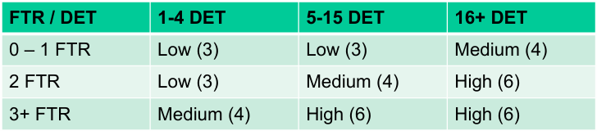
EO/EQ:
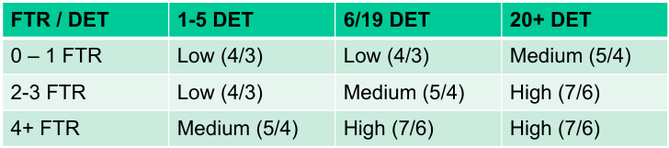
in order to have the estimated complexity for each user story.
Once we had the complexity, we have assigned to each story its respective points.

